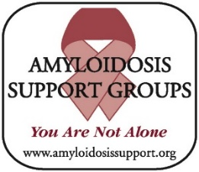

**AMYLOIDOSIS SUPPORT GROUPS**

**Virginia, D.C., Maryland**

**Saturday, April 5, 2025**

**GUESTS:**

**Cardiologists**

Drs**.** Ibrahim Saeed, Timothy Welch, Sumeet Mitter, Farooq Sheikh,

Joban Vaishnav,

**Cardio-Oncologist**

Dr. Ana Barac

**Oncologists**

Drs. Amitabha Sarma, Marion Cole, Carol Ann Huff

**Nephrologists**

Dr. Neeraja Tandra,

Carmen Elena Cervantes,

**Genetic Counselor**

Emily Brown

**Neurogastroenterologist**

Dr. Robert Bulat

**LOCATION:**

**Inova Center for Personalized Health**

**8100 Innovation Park Dr, 2nd Floor, Fairfax, 22031**

**TIME:**

**AL Registration & Coffee**

**7:30 -8:30**

**Meeting 8:30-11:30**

**Lunch 11:30-12:30**

**ATTR Registration & Lunch 11:30-12:30**

**Meeting 12:30 -3:30**

**Questions: Email Info@AmyloidosisSupport.org**

**RSVP To:**

**[Info@AmyloidosisSupport.org](mailto:Info@AmyloidosisSupport.org)**

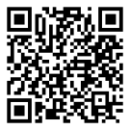

**Scan QR Code to Register**

[**www.AmyloidosisSupport.org**](http://www.AmyloidosisSupport.org)